Technical Documentation
AI-Powered Regulatory Compliance Management System
Green Link Digital Bank (GLDB)

1. Introduction
Purpose
This technical documentation describes the installation, configuration, deployment, and maintenance procedures for the AI-Powered Regulatory Compliance Management System developed for Green Link Digital Bank (GLDB). It is intended for developers, testers, and system administrators who require sufficient technical knowledge to deploy and maintain the system.
2. System Requirements
Before installing the AI-Powered Regulatory Compliance Management System, ensure that the following software components and services are available. These requirements are necessary for the system to function correctly during development and deployment.
Component | Requirement
Runtime | Node.js v18+
Database | MySQL 8+ (Azure or Local)
Vector Database | Pinecone (Cloud-hosted)
AI/LLM | OpenAI API Key (GPT-4o-mini)
Email | Gmail account with App Password
Browser Engine | Puppeteer (bundled Chromium for URL scraping)
Operating System | Windows, macOS, or Linux

3. Project Setup
3.1 Clone the Repository
The project source is hosted on GitHub. Clone the repository to the local machine before proceeding with the installation.
git clone https://github.com/MinThu63/Automated-Regulatory-and-Compliance-Management-System-V2.git
cd Automated-Regulatory-and-Compliance-Management-System-V2
3.2 Install Dependencies
Install all project dependencies defined in the package.json file using npm.
npm install
This command installs the required project dependencies including: express, mysql2, openai, puppeteer, pdf-parse, multer, axios, cheerio, nodemailer, bcryptjs, node-cron, @pinecone-database/pinecone.

3.3 Configure Environment Variables
Create a .env file in the project root with:
DB_HOST=your-mysql-host
DB_USER=your-db-user
DB_PASSWORD=your-db-password
DB_NAME=your-db-name
DB_PORT=3306
API_PORT=3000

OPENAI_API_KEY=sk-your-openai-key
OPENAI_MODEL=gpt-4o-mini

PINECONE_API_KEY=your-pinecone-key
PINECONE_INDEX=gldb-compliance

EMAIL_USER=your-email@gmail.com
EMAIL_PASS=your-gmail-app-password
EMAIL_RECIPIENT=your-email@gmail.com

Important: The .env file contains sensitive credentials and should not be committed to the Git repository. It is excluded through the .gitignore file.

3.4 Set Up the Database
Open MySQL Workbench or any MySQL client and run:
source schema.sql;
Executing the SQL script creates the following database objects:
- The database “SOI-2026-0039-MinThu”
- 14 tables (users, regulations, regulation_changes, alerts, internal_policies, compliance_gaps, tasks, audit_logs, departments, task_gaps, task_alerts, policy_proposals, policy_versions)
- Seed data (3 users, 5 regulatory sources, 1 seed regulation, 15 internal policies with procedures, 3 training programs, 6 departments)

3.5 Set Up Pinecone
- Go to https://app.pinecone.io
- Create an index named “gldb-compliance”
- Dimension: 1536 (for text-embedding-3-small)
- Metric: cosine
- Copy the API key to your .env
3.6 Set Up Gmail App Password
- Go to https://myaccount.google.com/apppasswords
- Generate an app password for "Mail"
- Copy the 16-character password to “EMAIL_PASS” in .env

4. Running the Server
Start the application by executing the following command from the project root directory:
npm start
Expected output:
Server is running on port 3000
Database connected successfully to SOI-2026-0039-MinThu
╔══════════════════════════════════════════╗
║ AGENTIC SYSTEM — Starting Agents ║
╚══════════════════════════════════════════╝
[Orchestrator] All 7 agents active
[Orchestrator] Flow: Scraper → Assessor → Analyzer → Dispatcher/Advisor → Notifier
[RAG] Pinecone connected — Index: gldb-compliance
If the above messages are displayed without errors, the application has started successfully and is ready to process incoming requests.

5. System Architecture
5.1 Architecture Overview
The AI-Powered Regulatory Compliance Management System adopts a modular architecture to support regulatory monitoring, AI-powered compliance analysis, and policy management. The system consists of a Node.js backend, a MySQL database, a Pinecone vector database for Retrieval-Augmented Generation (RAG), and OpenAI GPT-4o-mini for AI processing. Regulatory data is collected from external regulatory authorities through web scraping and official APIs. The frontend communicates with the backend through RESTful APIs to provide compliance officers with dashboards, task management, and reporting features.
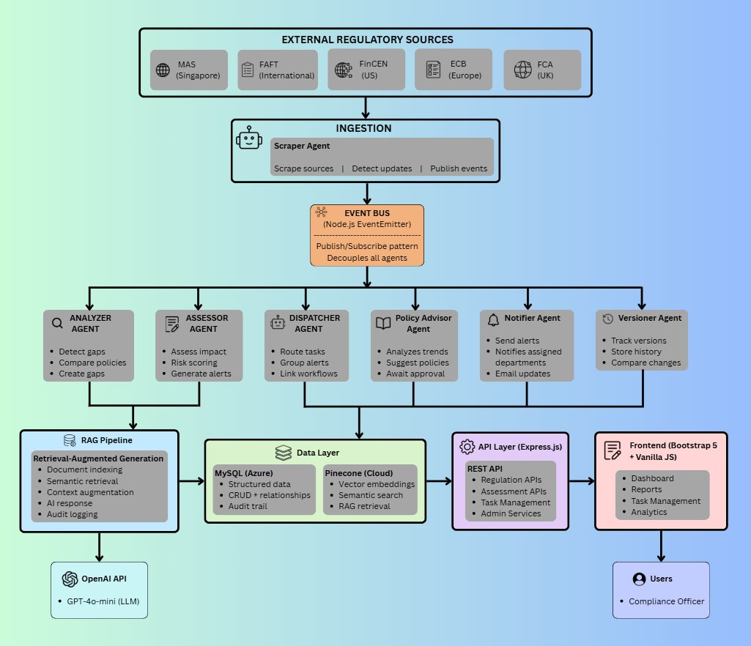
Figure 5.1. Overall system architecture of the AI-Powered Regulatory Compliance Management System.

Architecture Components
Component | Description
External Regulatory Sources | Regulatory updates are collected from MAS, FATF, FinCEN, ECB, and FCA through web scraping and official APIs.
Ingestion Layer | The Scraper Agent retrieves regulatory updates, detects changes, and publishes events for further processing.
Event Bus | Uses the Node.js EventEmitter to enable asynchronous communication between AI agents without direct dependencies.
AI Agents | Specialized agents perform impact assessment, compliance gap analysis, task generation, policy recommendation, notification, and version management.
RAG Pipeline | Retrieves relevant regulatory documents from Pinecone to provide contextual information for AI analysis before interacting with the OpenAI model.
Data Layer | Stores structured regulatory data, compliance records, audit logs, and vector embeddings using MySQL and Pinecone.
API Layer | Provides RESTful APIs that allow the frontend to interact with backend services.
Frontend | Displays dashboards, compliance reports, task management, and analytics for compliance officers and administrators.

6. Troubleshooting
The following table lists common issues that may occur during the installation or execution of the AI-Powered Regulatory Compliance Management System, along with their possible causes and recommended solutions.
Issue | Recommended Solution
Cannot connect to the server during login | Ensure the application server is running using npm start and verify that port 3000 is available.
Port 3000 already in use (EADDRINUSE) | Stop the existing Node.js process using Task Manager or terminate the process before restarting the application.
Compliance dashboard displays blank affected areas | Restart the application server to allow the AI backfill process to repopulate missing records.
PDF upload fails | Verify that the uploaded PDF is valid, does not exceed the file size limit, and that the required dependencies are installed.
URL scraping fails | Ensure the target website is accessible and that the Chromium browser required by Puppeteer is installed correctly.
Email notifications fail | Verify the Gmail App Password and SMTP configuration in the .env file.
Version comparison page displays no results | Ensure that both the previous and latest versions of the regulation exist in the database before performing the comparison.
Slow initial response after deployment | This may occur when the application is hosted on the free Render plan. The first request after a period of inactivity may take longer while the service starts.

7. Deployment
The AI-Powered Regulatory Compliance Management System is deployed using Render as the cloud hosting platform. Before deploying the application, complete the following steps to ensure that all required services and configurations are correctly set up.
Deployment Procedure
Step | Description
1 | Push the latest source code to the GitHub repository.
2 | Create a new Web Service on Render and connect it to the GitHub repository.
3 | Configure the build command: npm install && npx puppeteer browsers install chrome
4 | Configure the start command: node server.js
5 | Add all required environment variables in the Render dashboard.
6 | Verify that the Azure MySQL database accepts connections from the deployed application.
7 | Test user login using the Render deployment URL.
8 | Confirm that all AI agents start successfully by checking the Render logs.
9 | Test the email notification feature to ensure SMTP is configured correctly.

After completing the deployment process, verify that the application is accessible through the generated Render URL and that all core features, including regulatory scraping, AI analysis, database connectivity, and email notifications, are functioning correctly.
8. Maintenance
Regular maintenance ensures that the AI-Powered Regulatory Compliance Management System continues to operate efficiently and remains up to date with changing regulatory requirements. The following maintenance activities should be performed by system administrators.
Maintenance Task | Description
Adding New Regulatory Sources | New regulatory sources can be added through the Sources page in the web application or directly by inserting new records into the regulatory_sources database table.
Updating Internal Policies | Internal policies can be updated through the Policies page. Previous versions are automatically archived, and AI-generated policy recommendations can be reviewed and accepted where appropriate.
Monitoring Agent Activity | Monitor the Audit Trail and Agent Activity Breakdown dashboard to review AI agent performance, execution counts, and system activities.
Database Backup | The Azure MySQL database provides automated backups to protect against data loss and support disaster recovery.
Source Code Management | The latest version of the application source code is maintained in the GitHub repository to support version control and collaborative development.
Pinecone Vector Index | The Pinecone vector database is regenerated from the stored regulatory content during server startup, ensuring that vector embeddings remain synchronized with the latest data.

